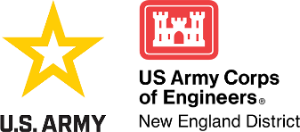
SPECIAL PUBLIC NOTICE

Public Notice Date: January 8, 2025
In Reply Refer to: Mr. Taylor Bell
Phone: (978) 318-8952
Email: Taylor.m.bell@usace.army.mil
____________________________________________________________

NOTICE OF AVAILABILITY OF STREAM CREDITS FOR SALE BY AUDUBON CONNECTICUT IN-LIEU FEE PROGRAM

SUBJECT:

This notice informs the public of availability of stream credits to be sold by the Audubon Connecticut In-Lieu Fee (ILF) Program.

BACKGROUND:

An ILF program involves the restoration, establishment, re-establishment, enhancement, rehabilitation, and/or preservation of aquatic resources through funds paid to a governmental or non-profit natural resources management entity to satisfy compensatory mitigation requirements for Department of the Army permits. Similar to a mitigation bank, an ILF program sells compensatory mitigation credits to permittees whose obligation to provide compensatory mitigation is then transferred to the ILF program sponsor. The operation and use of an ILF program are governed by an ILF program instrument.

A group of federal and state regulatory and resource agency representatives known as the Interagency Review Team (IRT) oversees the establishment and management of the program. The IRT is chaired by the U.S. Army Corps of Engineers (USACE) and the primary role of the IRT is to facilitate the establishment of the ILF program through the development of an ILF Instrument. The IRT also reviews ILF mitigation proposals and provides comments to USACE. Ultimately, USACE approves the use of the ILF program for specific projects pursuant to Section 10 of the Rivers and Harbors Act of 1899 and/or Section 404 of the Clean Water Act (CWA). The USACE provides no guarantee that any individual or general permit proposing to use the ILF program for compensatory mitigation would be authorized.

The Audubon Connecticut ILF Program currently has 5,000 advanced stream credits available to sell across each of their service areas. These credits were authorized to be sold in the original ILF agreement entitled “Final Instrument for the Audubon Connecticut In-Lieu Fee Program Sponsored by National Audubon Society, Inc.” dated August 21, 2013. The instrument includes details about the ILF Program goals and objectives in general and can be found at the following link: http://www.nae.usace.army.mil/Portals/74/docs/regulatory/Mitigation/CTILFProgramInstrument.pdf.

ACTION:

Enclosed is the updated Fact Sheet for the Audubon Connecticut ILF Program displaying the cost for stream and wetland credits.

PURPOSE:

The purpose of this notice is to provide transparency for stakeholders who may be considering using the Audubon Connecticut ILF Program to meet compensatory mitigation requirements for future actions that may require permits from USACE.

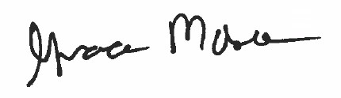

Grace Moses
Chief, Technical Support Branch
Regulatory Division

---------------------------------------------------------------------------------------------------------------------
Please contact Ms. Tina Chaisson at bettina.m.chaisson@usace.army.mil or
(978) 318-8058 if you would like to be removed from our public notice mailing list.

